**Assignment No:-4**

Name:-Suryawanshi Sangramsingh Sambhaji

Batch:-April Date:-2/5/2024

**1. Write a program to take input a no and print table.**

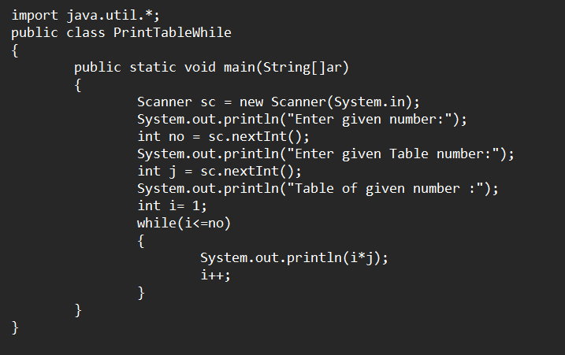

**Output:**

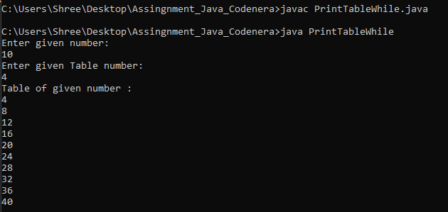

**2. Write a program to find factorial of a no.**

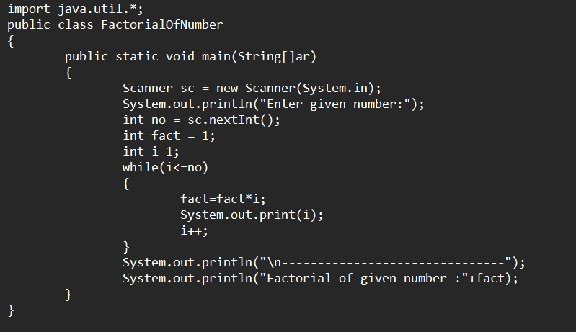

**Output:**

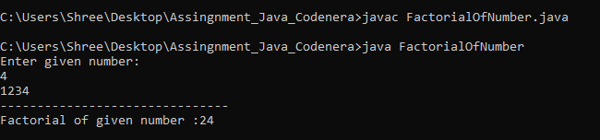

**3.** **Find the even and odd number from n digit number.**

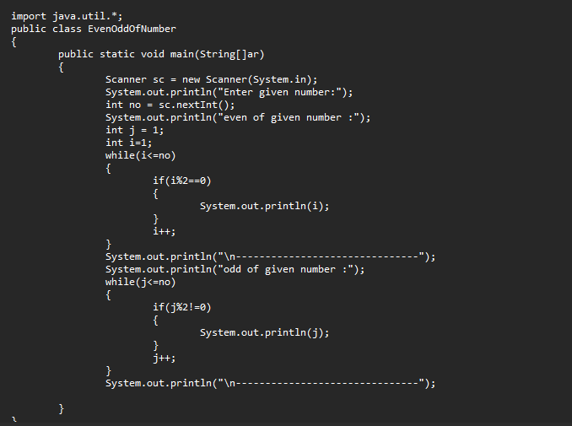

**Output:**

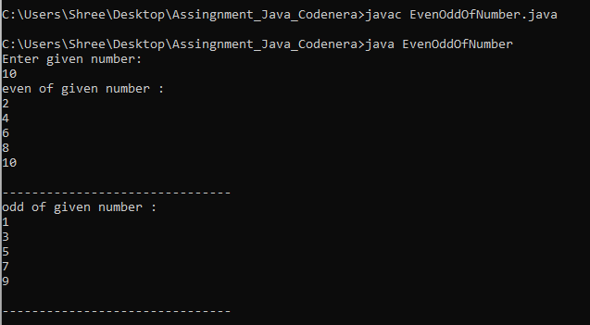

**4. Find the sum of n digit number.**

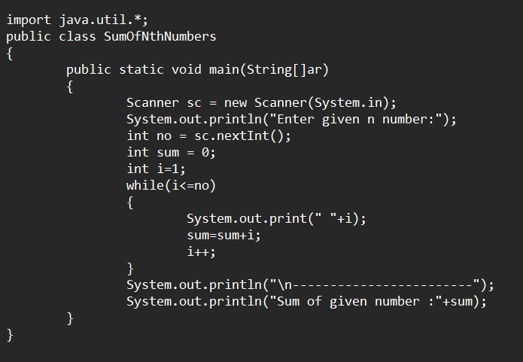**Output:**

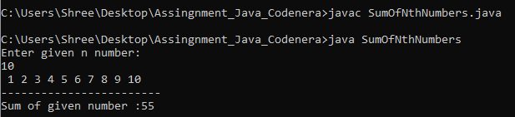

**5. Write a program to add multiple number, ask user to take input as their need.**

**Press 0 to terminate inputting after that calculate sum of that inputted number.**

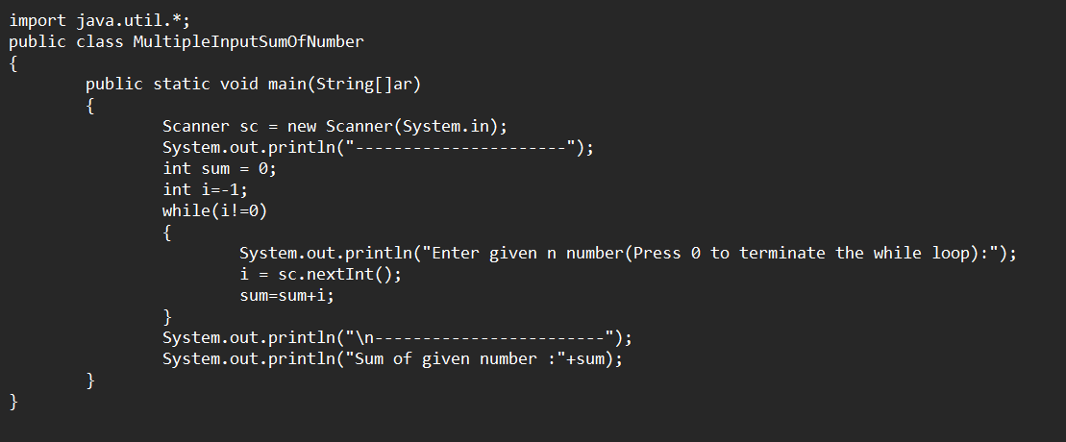**Output:**

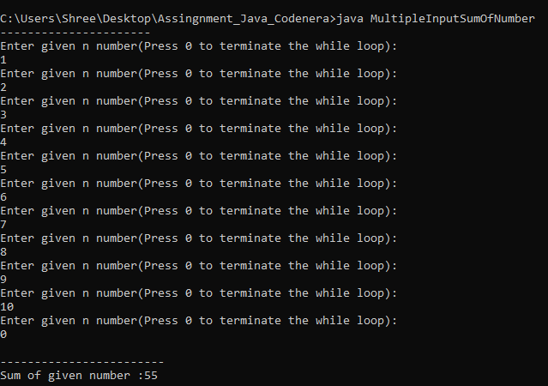

**6. Find the sum of even number of n digit number.**

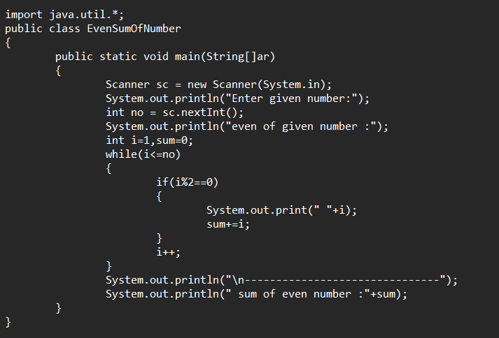**Output:**

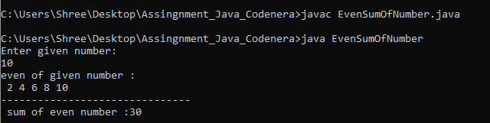

**7. Reverse the Given number.**

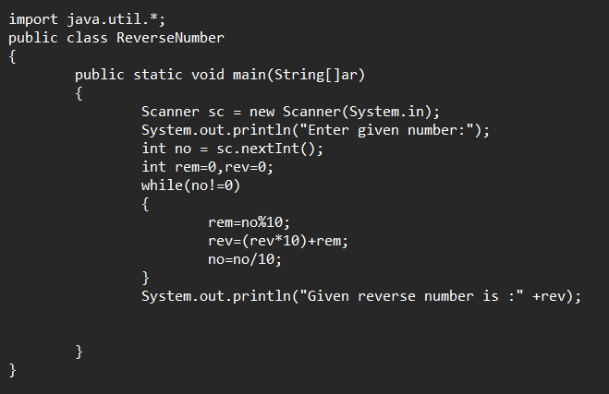**Output:**

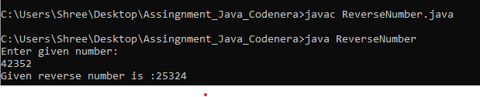

**8. Write a program to check given number is palindrome number or not.**

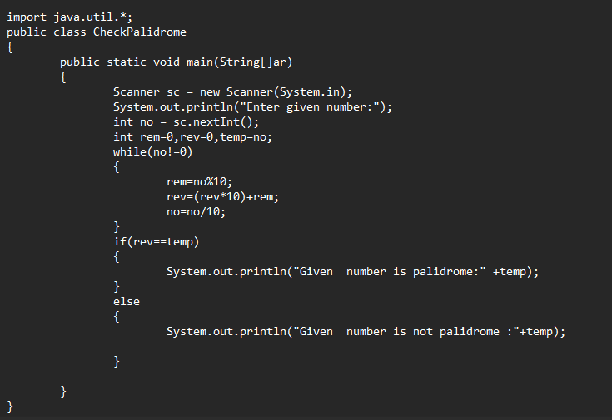**Output:**

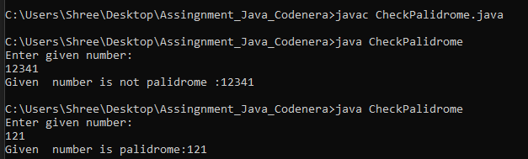

**9. Find the max number from n digit number.**

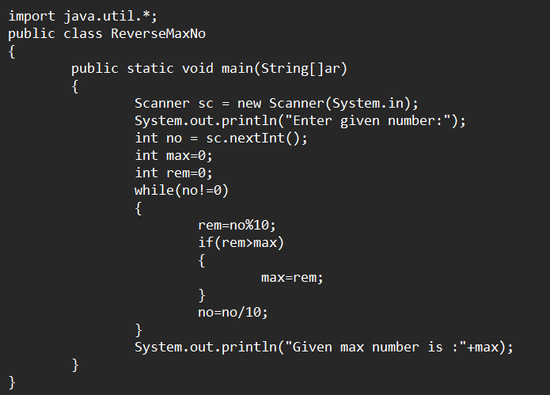**Output:**

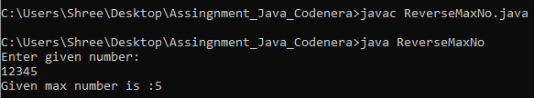

**10. Find the min number from n digit number.**

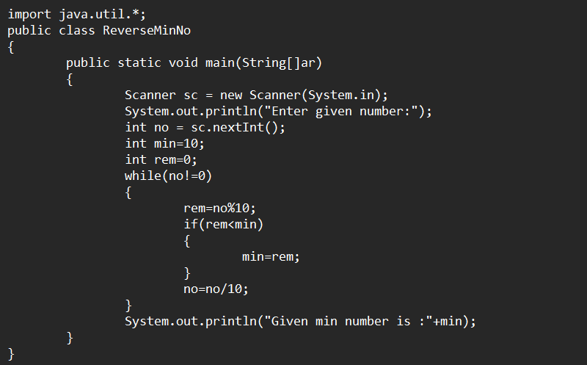**Output:**

